Message Center SHMI Displays Menu Memory Control Function – CGEA1.3

Functional Description

The Message Center SHMI Displays Menu Memory Control Function is intended for use in instrument clusters with a 4.2" LCD or similar display. It is not intended for use on instrument clusters with a B, E or F display.

The Menu Memory Control Function allows the user to setup how the Message Center will navigate through the menus. In the Standard Menu Memory Mode, the driver can scroll up and down to the next Main Menu selection from a Home Page with an Up or Down message center switch button press, respectively. The driver must enter a new Home Page through the Main Menu. In the Memory On Menu Memory Mode, the driver can scroll up and down through the current selection of each Home Page with an Up or Down message center switch button press, respectively, without going back to the Main Menu.

Interfaces

Interface Context Diagram (I/O Block Diagram)
Figure 1.1 Menu Memory Function Context Diagram
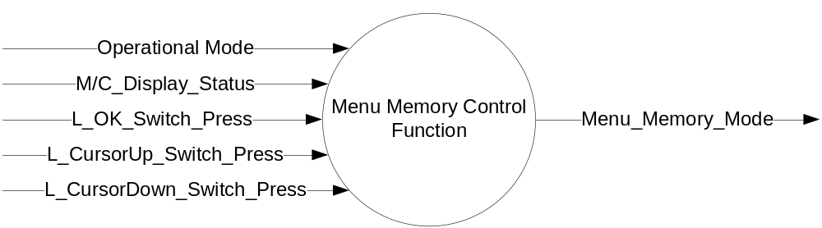

Inputs

- INTERNAL:
  - Operational_Mode
  - M/C_Display_Status
  - L_OK_Switch_Press
  - L_CursorUp_Switch_Press
  - L_CursorDown_Switch_Press

Outputs
- Menu_Memory_Mode

Function/Performance

Operational Modes

Mode | Differentiating Vehicle Conditions
Sleep Mode | Menu Memory Function Off
Limited Mode | Menu Memory Function Off
Normal Mode | Menu Memory Function Functioning
Crank Mode | Menu Memory Function Functioning

Voltage Levels

Refer to Cluster Features table located in Operational Modes and Voltage Range Strategies Section in this SPSS.

Human-Machine Interface

Visual

Indicator Graphics / Display Format
Resetting to System Default values is achieved through the "Settings" menus. The following System Reset Displays are only Graphic Representations. See Ford Studio released Drawing and VAPS model for exact graphics.

Menu level 3 |  | Menu level 4 | Confirmation Text
Menu Control |  | T: Menu Control S: 4:4
Menu Control | ☑ | Standard | Menu Control Set to STANDARD
Menu Control |  | Memory On | Menu Control Set to MEMORY ON

Indicator Color Coordinates

As per Ford Studio Drawing

Audio

None

Switch Control Logic

Consumer access to the Menu Memory Control Function’s display shall be as specified in the Message Center_SHMI Displays_5 Button Interface (STSS).

System Accuracy

- Within a 100msec of receiving a message/input that results in a change of state the cluster will update the display to the proper status.

Operation: Performance and Functional

Subsystem Algorithm Flowchart / State Diagram

Figure 1.2 Subsystem Flowchart
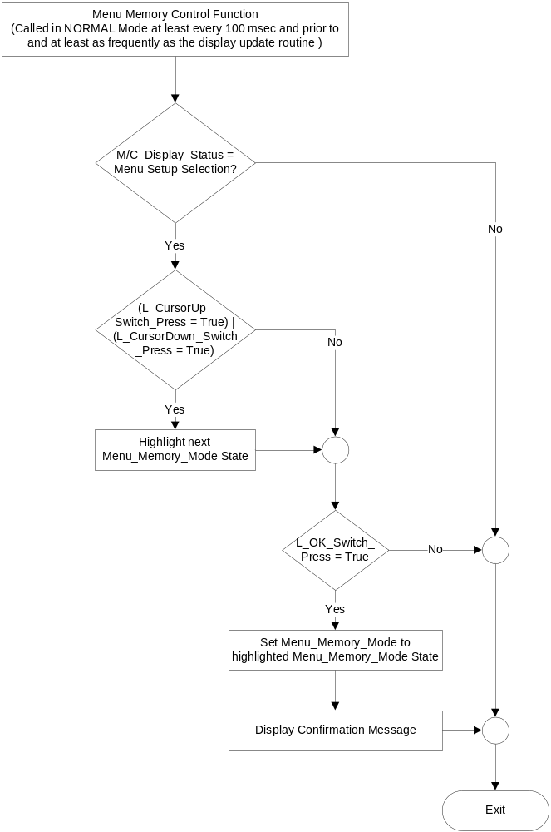

Current Menu_Memory_Mode State | Next Menu_Memory_Mode State | Confirmation Text for a Temporary Pop-Up
☑ Standard (0x0)  ◻ Memory On (0x1) | ◻ Standard (0x0)  ☑ Memory On (0x1) | Menu Control Set to  STANDARD
◻ Standard (0x0)  ☑ Memory On (0x1) | ☑ Standard (0x0)  ◻ Memory On (0x1) | Menu Control Set to  MEMORY ON

The confirmation screen is a Program definable characteristic that could be either a unique Temporary Pop-Up Confirmation Screen or an indication of the new selection using the Settings Menu

Operation Description (supports algorithm flowchart /state diagram)

The Menu Memory Control Function allows the user to setup how the Message Center will navigate through the menus. When in the Menu Setup page, an Up or Down message center button press will highlight the next Menu Setup selection. An OK message center button press while on this page will set the Menu_Memory_Mode output to the highlighted selection and a confirmation message will be displayed.

- When Menu_Memory_ Mode = Standard, the navigation of the M/C from a Home Page for up and down will be to the next Main Menu selection up or down, respectively. The driver must enter a new Home Page through the Main Menu.
- When Menu_Memory_ Mode = Memory On, the navigation of the M/C from a Home Page for up and down will be to the current selection of the Home Page above or below the current page, respectively, without going back to the Main Menu.

Function Safety Classification (EMC)

Class B

Memory Storage
Parameter Name | Description | Value at Battery connect | Value at  Module Wake-up
M/C_Display_Status | Input to this routine that is a State Indicator to identify which text is currently being displayed on Message Center display. | See Message Center_SHMI Displays_5 Button Interface STSS | See Message Center_SHMI Displays_5 Button Interface STSS
Operational_Mode | Input to this routine that is a 4 State indicator for cluster operational mode | As per Operational Modes and Voltage Range Strategies Section (STSS) | As per Operational Modes and Voltage Range Strategies Section (STSS)
Menu_Memory_Mode | Output that controls how the driver navigates through the Message Center menus. | Standard (0x0) | Do not init
L_OK_Switch_Press | Reference Message Center Switch - 5 Button HSCAN Interface STSS
L_CursorUp_Switch_Press | Reference Message Center Switch - 5 Button HSCAN Interface STSS
L_CursorDown_Switch_Press | Reference Message Center Switch - 5 Button HSCAN Interface STSS

Prove Out

No

Reconfigurable Telltale

No

Message Center Msg

Refer to Ford Studio Drawing

Error Handling

Missing Message Strategy

There is no missing message strategy for this STSS.

Diagnostics

Self Test

None

Engineering Test Mode

Reference section “Dealer / Engineering Test Mode (ETM)”

Part II Performance

Supported Diagnostic Trouble Codes (DTCs)
DTC | Description | When Logged

DID DE00
Block  Num | Block Description | Byte(s) | Bits | State: Description | "0" | "1" | Default | Comments/  Information
PACKETED BLOCKS
$00 | Option Content (B&A) | *

Reference Specification

IS-0344 GENERAL REQUIREMENTS (MSGCENTR)
IS-0379 NORTH AMERICAN WARNINGS AND INDICATORS STRATEGY
Spec Instrument Panel Cluster (IPC) Infotainment Subsystem Part Specific Specification (SPSS)

Revision History

SPSS Module Revision History

Revision Level | Name | Change Description | Date
1.0 | V. Patel | Initial release for CGEA1.3  Based on Message Center SHMI Displays Menu Memory Control Function CGEA STSS v1.4  No updates required. | 5/11/2010

